10. Implementation of primitive and non-primitive data types using Constructor DI with XML configuration and ApplicationContext

Below is a single Spring Core XML project that demonstrates Constructor DI for ALL data types in one project:
- ✔ Primitive types
✔ Wrapper classes
✔ String
✔ Arrays
✔ Collections (List, Set, Map)
✔ Non-primitive (custom object)

1. Primitive Data Types
Definition:
Primitive data types are basic built-in data types in Java that store simple values and are not objects.
Examples:
int, double, float, boolean, char, long
In Spring DI:
Primitive values are injected using the value attribute.
Categories of Non-Primitive Data Types
Non-primitive data types are reference types that store the address (reference) of objects.
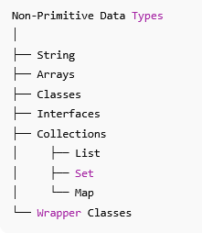

2. Wrapper Classes
Wrapper classes are object representations of primitive types provided by Java to allow primitives to be used as objects.
Examples:
Integer, Double, Float, Boolean, Character
Why needed:
- Required for collections
- Allows null values
- Supports object-based features
In Spring DI:
Injected the same way as primitives using value.

3. String
Definition:
String is a non-primitive, immutable class in Java used to store textual data.
Example:
String name = "Rama";
In Spring DI:
Injected using value attribute.
<constructor-arg value="Rama"/>

4. Arrays
An array is a fixed-size collection of elements of the same data type, stored in contiguous memory locations.
“Fixed size” means the size of an array is decided at the time of creation and cannot be changed later.

Example:
String[] skills = {"Java", "Spring"};
In Spring DI:
Injected using <list> inside constructor arguments.
<constructor-arg>
<list>
<value>Java</value>
<value>Spring</value>
</list>
</constructor-arg>

✔ 5. Collections (List, Set, Map)
Collections are dynamic data structures provided by the Java Collection Framework to store multiple objects.

Feature | List | Set | Map
Type | Collection | Collection | Not a Collection (Map interface)
Storage | Stores elements | Stores unique elements | Stores key–value pairs
Duplicates | ✅ Allowed | ❌ Not allowed | ❌ Keys not allowed (values can repeat)
Order | ✅ Maintains insertion order | ❌ No guarantee (LinkedHashSet maintains order) | ❌ No guarantee (LinkedHashMap maintains order)
Index based | ✅ Yes (index starts from 0) | ❌ No index | ❌ No index
Null values | ✅ Multiple allowed | ✅ Only one null | ✅ One null key, multiple null values
Access method | By index (get(index)) | By iteration only | By key (get(key))
Example implementations | ArrayList, LinkedList | HashSet, LinkedHashSet | HashMap, LinkedHashMap
Use case | Ordered data with duplicates | Unique elements | Key-based data storage
Spring XML tag | <list> | <set> | <map>

List – Syntax & Example

Syntax: List<DataType> listName = new ArrayList<>();

Example
import java.util.*;

public class ListExample {
public static void main(String[] args) {

List<String> names = new ArrayList<>();

names.add("Rama");
names.add("Sita");
names.add("Rama"); // duplicates allowed

System.out.println(names);
System.out.println(names.get(0)); // index based
}
}

Output
[Rama, Sita, Rama]
Rama

Key Points:
- Allows duplicates
- Maintains insertion order
- Index based access

2 Set – Syntax & Example

Syntax: Set<DataType> setName = new HashSet<>();

Example
import java.util.*;

public class SetExample {
public static void main(String[] args) {

Set<String> cities = new HashSet<>();

cities.add("Hyderabad");
cities.add("Delhi");
cities.add("Hyderabad"); // duplicate ignored

System.out.println(cities);
}
}

Output (order may vary)
[Delhi, Hyderabad]

Key Points
- No duplicates
- No index
- Order not guaranteed

3 Map – Syntax & Example

Syntax: Map<KeyType, ValueType> mapName = new HashMap<>();

Example
import java.util.*;

public class MapExample {
public static void main(String[] args) {

Map<Integer, String> students = new HashMap<>();

students.put(101, "Rama");
students.put(102, "Sita");
students.put(101, "Krishna"); // overwrites value

System.out.println(students);
System.out.println(students.get(101)); // key based
}
}

Output:
{101=Krishna, 102=Sita} Krishna

Key Points
- Stores key–value pairs
- Keys must be unique
- Accessed using key

Spring IoC container interfaces and XML configuration

ApplicationContext and BeanFactory are Spring IoC container interfaces.
They are responsible for creating, managing, and injecting Spring beans.
BeanFactory is the basic Spring IoC container that provides fundamental features to manage beans.

Key Points
- Oldest Spring container
- Creates beans only when requested (lazy loading)
- Lightweight
- Basic DI support

Example
BeanFactory factory =
new XmlBeanFactory(new ClassPathResource("applicationContext.xml"));

Student s = (Student) factory.getBean("student");
NOTE: Bean is created only at getBean() call

ApplicationContext?

ApplicationContext is an advanced IoC container built on top of BeanFactory, providing enterprise-level features.

Key Points
- Superset of BeanFactory
- Creates beans at startup (eager loading)
- Supports AOP, events, i18n, annotations, etc.
- Most commonly used container

Example
ApplicationContext context =
new ClassPathXmlApplicationContext("applicationContext.xml");

Student s = context.getBean("student", Student.class);
📌 Beans created when context loads

Difference Between ApplicationContext and BeanFactory
Feature | BeanFactory | ApplicationContext
Type | Basic IoC container | Advanced IoC container
Bean loading | Lazy (on demand) | Eager (startup)
Performance | Slightly faster startup | Slightly slower startup
Features | DI only | DI + AOP + Events + i18n
Annotation support | ❌ No | ✔ Yes
Enterprise support | ❌ Limited | ✔ Full
Common usage | Rare | Very common
Example class | XmlBeanFactory | ClassPathXmlApplicationContext

Simple Real-Life Analogy
- BeanFactory = Order food only when customer asks.
- ApplicationContext = Prepare food in advance for faster service.

Create a Spring Boot Project

STEP-BY-STEP: Spring Core XML Project in STS
- File → New → Maven Project
- Click Next
- Search for “maven-archetype-quickstart”
- Click Next
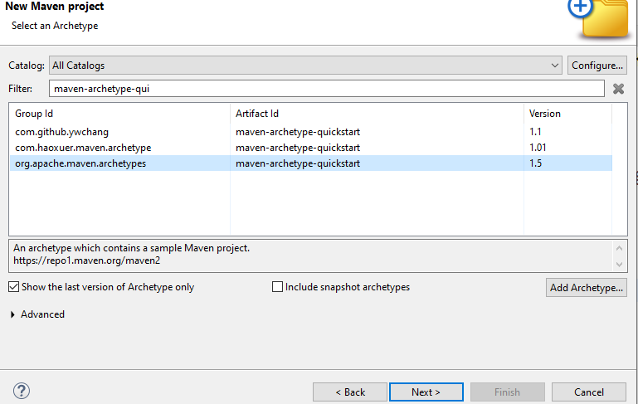

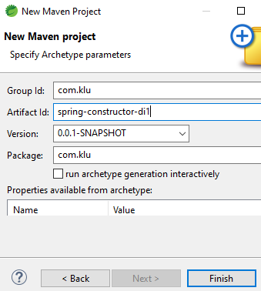
NOTE: Ensure the to “Uncheck” the checkbox: run archetype generationinteractively
Fill details:
Group Id : com.klu
Artifact Id : spring-constructor-di
Packaging : jar
Package : com.klu

Click Finish
👉 Maven project is created.
Open pom.xml and add inside <dependencies>:
---------------------------------------------------------------------
<dependency>
<groupId>org.springframework</groupId>
<artifactId>spring-context</artifactId>
<version>5.3.30</version>
</dependency>
-------------------------------------------------------------------------
Wait until:
- Maven downloads jars
Project Structure
Create the following project structure
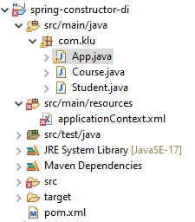
Create two classes (Course, Student) and
create a folder “resources” under src/main, inside this crate a applicationContext.xml file as shown above.

Create Non-Primitive Class (Course.java)

Course.java
-----------------------------------------------------------------
package com.klu;

public class Course {

private String courseName;
private int duration;

public Course(String courseName, int duration) {
this.courseName = courseName;
this.duration = duration;
}

public String getCourseName() {
return courseName;
}

public int getDuration() {
return duration;
}
}
----------------------------------------------------------------------------------

Create Bean with Primitive + Non-Primitive (Student.java)

Student.java
--------------------------------------------------------
package com.klu;

import java.util.List;
import java.util.Set;
import java.util.Map;

public class Student {

// Primitive types
private int id;
private double fee;
private boolean active;

// Wrapper classes
private Integer age;
private Double marks;

// String
private String name;

// Array
private String[] skills;

// Collections
private List<String> subjects;
private Set<String> hobbies;
private Map<String, Integer> semesterMarks;

// Non-primitive
private Course course;

// Constructor DI (ALL TYPES)
public Student(
int id,
String name,
double fee,
boolean active,
Integer age,
Double marks,
String[] skills,
List<String> subjects,
Set<String> hobbies,
Map<String, Integer> semesterMarks,
Course course)
{

this.id = id;
this.name = name;
this.fee = fee;
this.active = active;
this.age = age;
this.marks = marks;
this.skills = skills;
this.subjects = subjects;
this.hobbies = hobbies;
this.semesterMarks = semesterMarks;
this.course = course;
}

public void display() {
System.out.println("ID : " + id);
System.out.println("Name : " + name);
System.out.println("Fee : " + fee);
System.out.println("Active : " + active);
System.out.println("Age : " + age);
System.out.println("Marks : " + marks);

System.out.println("Skills:");
for (String s : skills) {
System.out.println(" - " + s);
}

System.out.println("Subjects : " + subjects);
System.out.println("Hobbies : " + hobbies);
System.out.println("Semester Marks: " + semesterMarks);

System.out.println("Course : " +
course.getCourseName() + " (" + course.getDuration() + " months)");
}
}
-----------------------------------------------------------------

Create XML Configuration File (applicationContext.xml) in the following folder.
Location: src/main/resources
------------------------------------------------------------------
<beans xmlns="http://www.springframework.org/schema/beans"
xmlns:xsi="http://www.w3.org/2001/XMLSchema-instance"
xsi:schemaLocation="
http://www.springframework.org/schema/beans
http://www.springframework.org/schema/beans/spring-beans.xsd">

<!-- Non-Primitive Bean -->
<bean id="course" class="com.klu.Course">
<constructor-arg value="Spring Framework"/>
<constructor-arg value="6"/>
</bean>

<!-- Bean with ALL Data Types -->
<bean id="student" class="com.klu.Student">

<!-- Primitive + String -->
<constructor-arg value="101"/>
<constructor-arg value="Rama"/>
<constructor-arg value="25000"/>
<constructor-arg value="true"/>

<!-- Wrapper classes -->
<constructor-arg value="22"/>
<constructor-arg value="89.5"/>

<!-- Array -->
<constructor-arg>
<list>
<value>Java</value>
<value>Spring</value>
<value>Hibernate</value>
</list>
</constructor-arg>

<!-- List -->
<constructor-arg>
<list>
<value>Maths</value>
<value>Physics</value>
<value>Computer Science</value>
</list>
</constructor-arg>

<!-- Set -->
<constructor-arg>
<set>
<value>Reading</value>
<value>Coding</value>
<value>Music</value>
</set>
</constructor-arg>

<!-- Map -->
<constructor-arg>
<map>
<entry key="Sem1" value="85"/>
<entry key="Sem2" value="88"/>
<entry key="Sem3" value="90"/>
</map>
</constructor-arg>

<!-- Non-Primitive -->
<constructor-arg ref="course"/>

</bean>

</beans>
----------------------------------------------------------

Copy the following code in the App.java Class (ApplicationContext IoC)

package com.klu;

import org.springframework.context.ApplicationContext;
import org.springframework.context.support.ClassPathXmlApplicationContext;
import com.klu.Student;

public class App {

public static void main(String[ ] args) {

ApplicationContext context =
new ClassPathXmlApplicationContext("applicationContext.xml");

Student student = context.getBean("student", Student.class);
student.display();
}
}
--------------------------------------------------------------------------------------------------------

Run the Application
- Right-click App.java
- Run As → Java Application
=================
OUTPUT
================
ID : 101
Name : Rama
Fee : 25000.0
Active : true
Age : 22
Marks : 89.5
Skills:
- Java
- Spring
- Hibernate
Subjects : [Maths, Physics, Computer Science]
Hobbies : [Reading, Coding, Music]
Semester Marks: {Sem1=85, Sem2=88, Sem3=90}
Course : Spring Framework (6 months)

If you not get error:
• Right-click project
• Maven → Update Project
- ✔ Force Update of Snapshots/Releases
- Click OK

Execution Flow
- JVM starts MainApp
- Spring loads applicationContext.xml
- Spring creates Course object
- Spring creates Student object
- Constructor DI injects:
  - primitives (id, name, …)
  - non-primitive (Course)
- Bean returned using getBean()
- Business logic executed

WHAT SPRING ACTUALLY DOES (INTERNALLY)

When this line runs:
new ClassPathXmlApplicationContext("applicationContext.xml");
Spring performs:
Course course = new Course("Spring Framework", 6);

Student student = new Student(
101,
"Rama",
25000,
true,
22,
89.5,
new String[]{"Java","Spring","Hibernate"},
List.of("Maths","Physics","Computer Science"),
Set.of("Reading","Coding","Music"),
Map.of("Sem1",85,"Sem2",88,"Sem3",90),
course
);
👉 THIS is Constructor DI

